ASSIGNMENT – 14.3
Veerla Sathvika
2303A52434
Batch: 38

Task 1: AI-Assisted Personal Portfolio Website
Scenario
A student wants to showcase academic projects, technical skills, and contact information through a personal portfolio website. AI tools are used to speed up development while maintaining quality and customization.
Tasks

Use GitHub Copilot to generate a semantic HTML structure with
sections:
  - Home
  - About
  - Projects
  - Contact

Ask Copilot to suggest responsive CSS using Flexbox or Grid.
- Customize AI-generated CSS to add:
  - Hover effects on project cards
  - Smooth scrolling navigation

Expected Outcome
- Clean and well-structured portfolio website
- Responsive layout for desktop and mobile screens
- Interactive project cards

PROMPT:

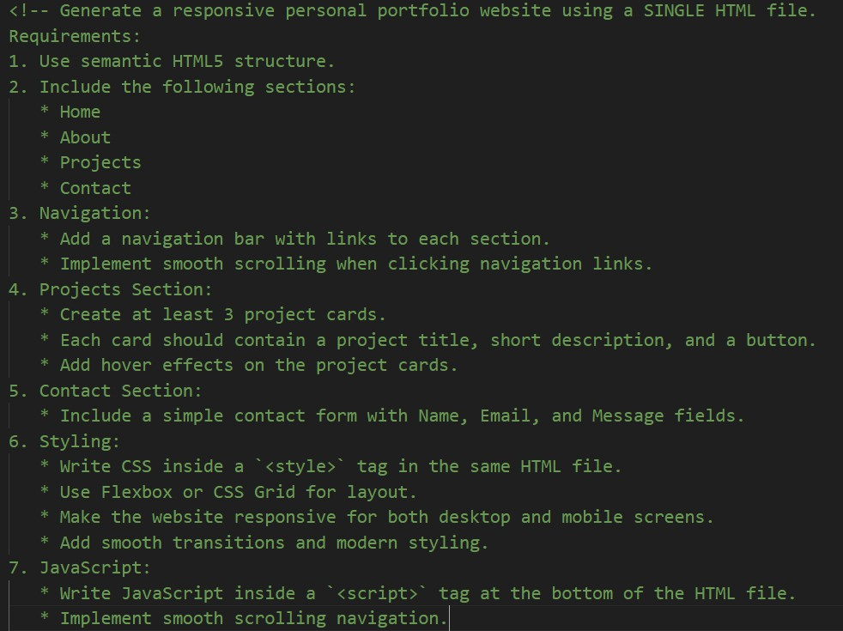
CODE:
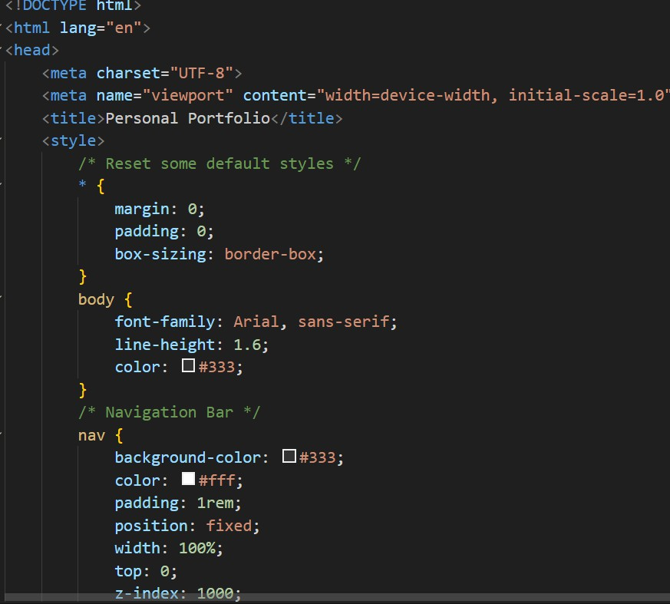

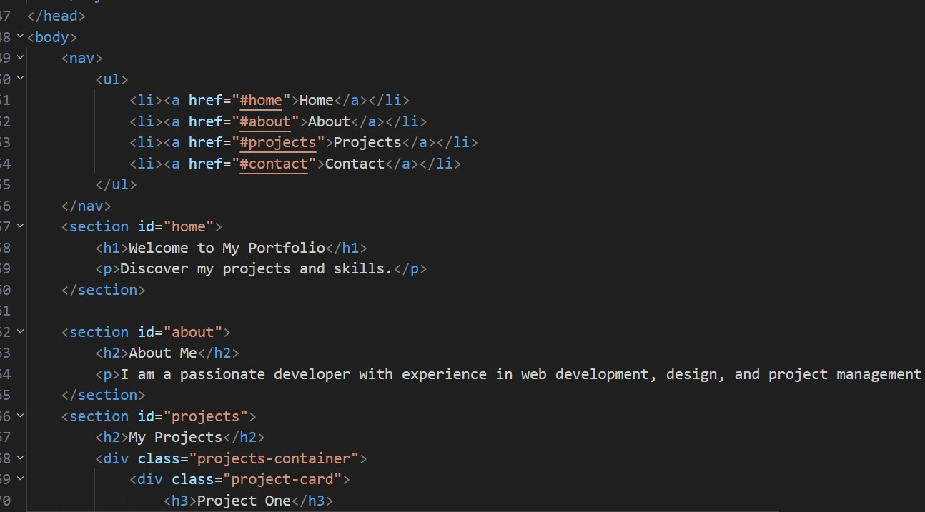
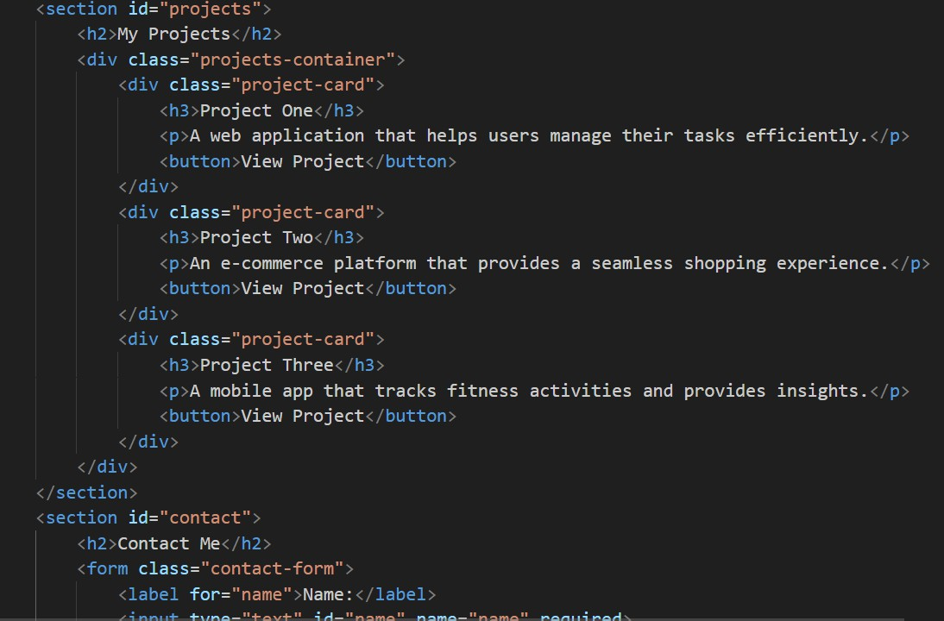


OUTPUT:

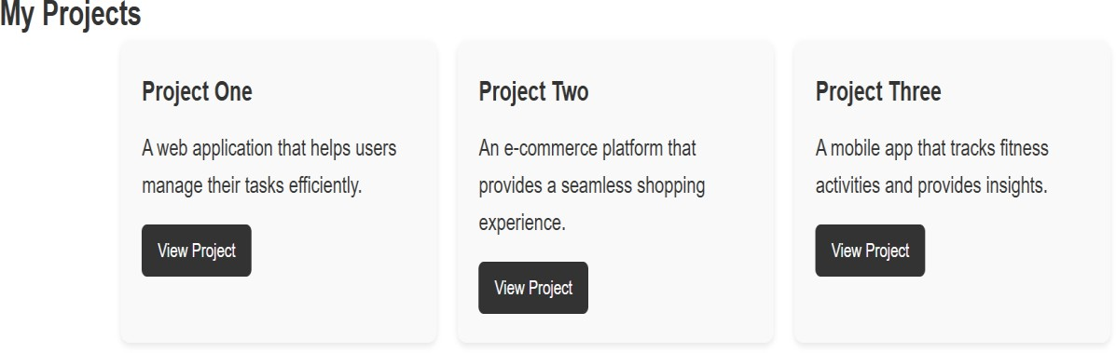

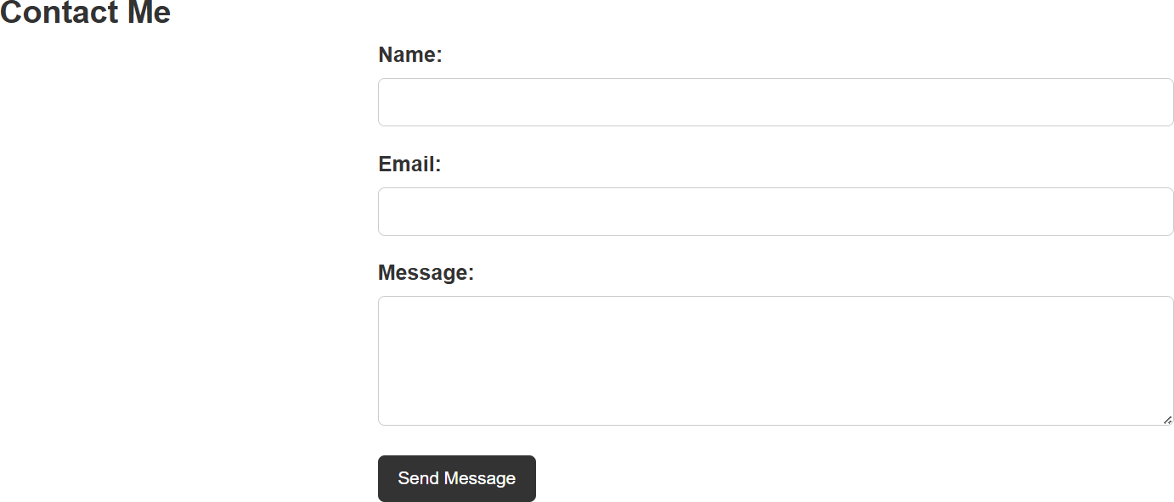

Task 2: AI-Generated Restaurant Landing Page
Scenario
A local restaurant requires a simple yet attractive landing page to display its offerings. The developer uses AI assistance to rapidly generate UI components. Tasks
- Use Copilot to create a navigation bar with links:
  - Home
  - Menu
  - Gallery
  - Contact
- Generate a menu section styled with CSS cards.
- Implement a JavaScript-based image slider for the gallery using Copilot suggestions.
- Customize animations or transitions for better user experience. Expected Outcome
- Fully functional restaurant landing page
- Responsive navigation bar
- Working image slider with smooth transitions

PROMPT:
Generate a responsive Restaurant Landing Page using a single HTML file with HTML, CSS, and JavaScript.
Requirements:
- HTML Structure:
  - Use semantic HTML5 elements.
  - Create the following sections:
    - Home
    - Menu
    - Gallery
    - Contact
- Navigation Bar:
  - Create a responsive navigation bar at the top of the page.
  - Include links for Home, Menu, Gallery, and Contact.

  - Implement smooth scrolling when clicking the navigation links.
- Menu Section:
  - Design a menu section displaying at least 4 food items.
  - Each item should be shown in a CSS card layout.
  - Each card should include:
    - Food image
    - Food name
    - Short description
    - Price
  - Add hover effects to the cards.
- Gallery Section:
  - Implement an image slider using JavaScript.
  - Display multiple restaurant or food images.
  - Include previous and next buttons for navigation.
  - Add smooth transition effects between images.
- Contact Section:
  - Add a simple contact form with fields:
    - Name
    - Email
    - Message
  - Include a submit button.
- Styling:
  - Write CSS inside a <style> tag.
  - Use Flexbox or CSS Grid for layout.
  - Add modern design with animations and smooth transitions.
  - Ensure the website is fully responsive for mobile and desktop screens.
- JavaScript:
  - Write JavaScript inside a <script> tag at the bottom of the HTML file.
  - Implement the image slider functionality.
  - Add smooth scrolling for navigation links.

CODE:
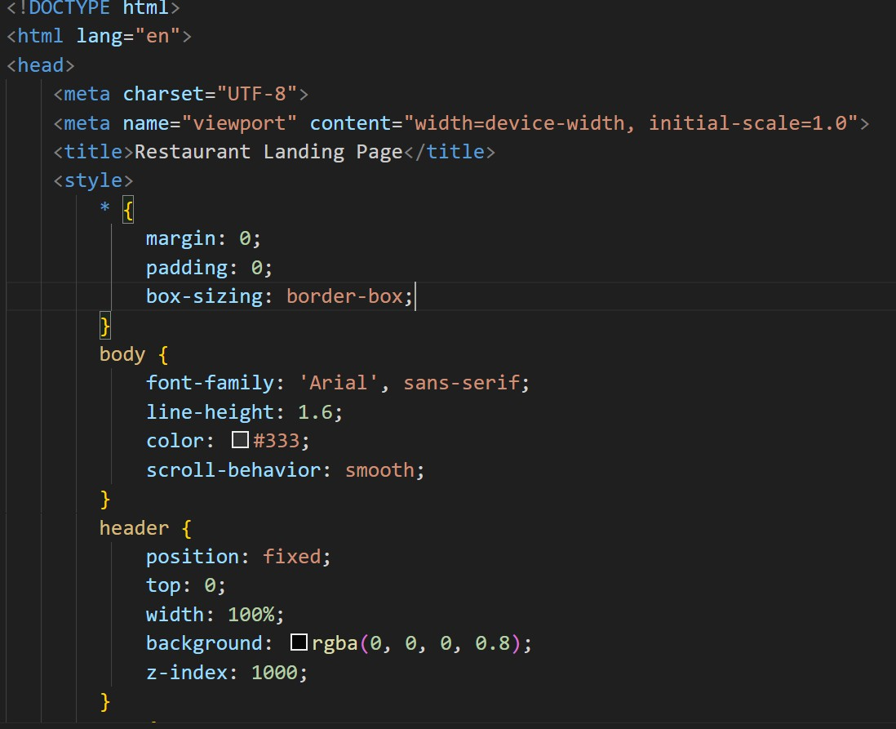
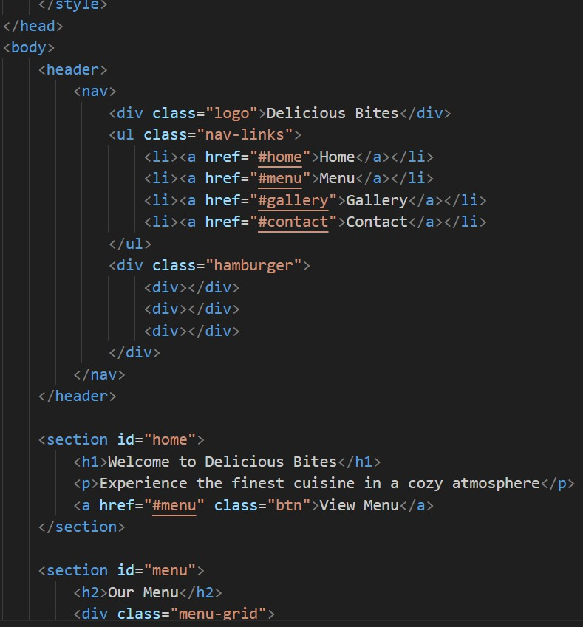

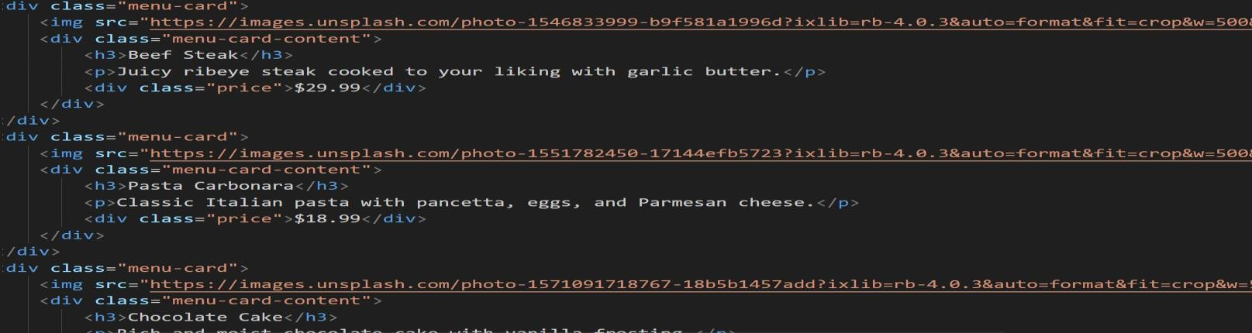
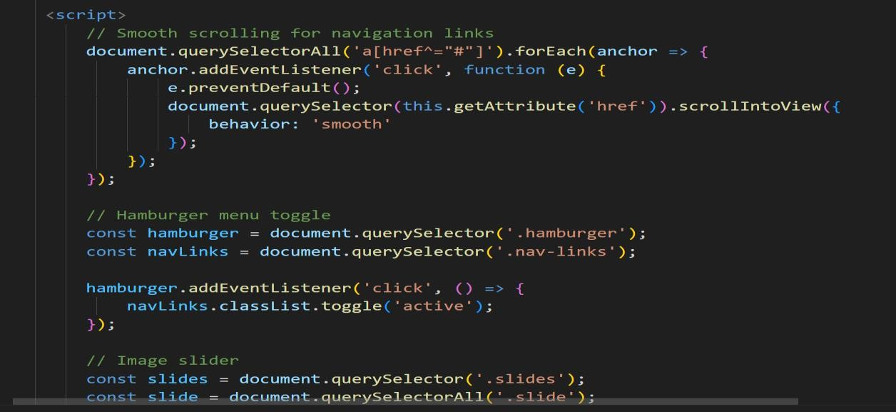
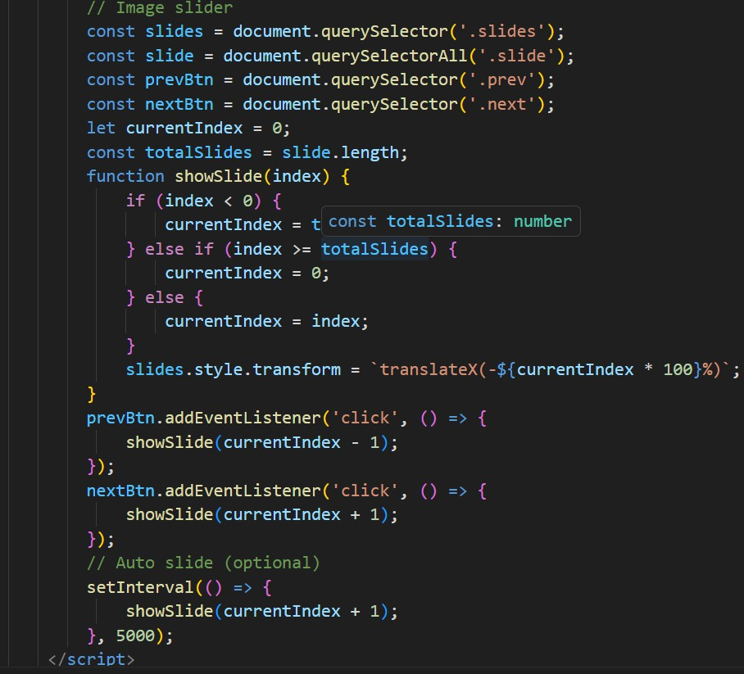

OUTPUT:

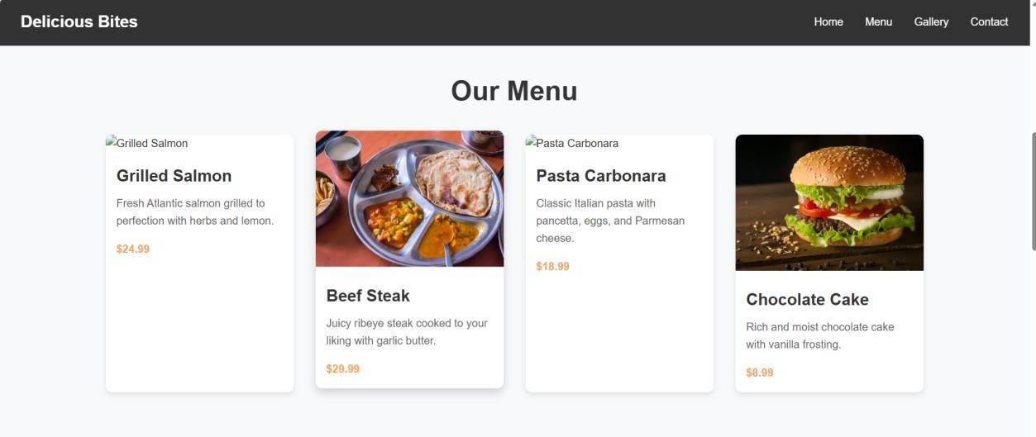
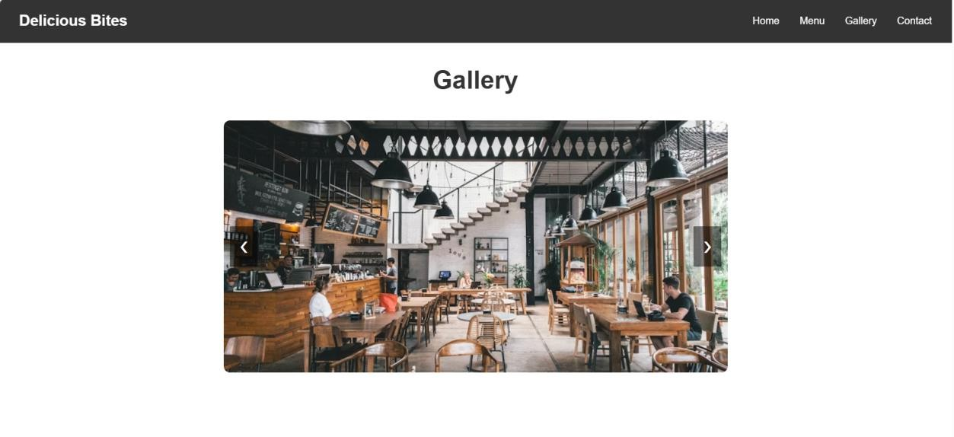

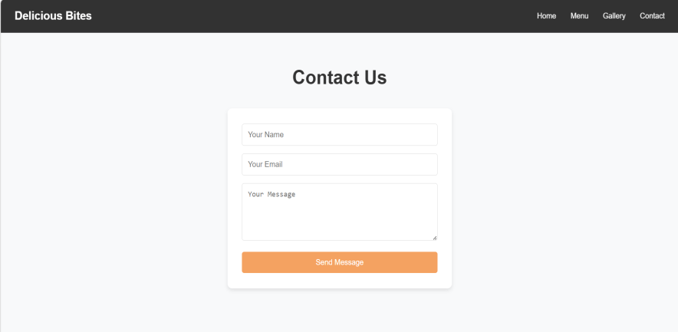
EXPLANATION:
This task creates a restaurant landing page using HTML, CSS, and JavaScript to display the
restaurant’s information in an attractive way. A navigation bar is added with links such as Home,
Menu, Gallery, and Contact to help users easily move between sections. The menu section is designed using CSS cards to present food items with images, descriptions, and prices. A JavaScript image slider is implemented in the gallery section to display images with smooth transitions and better user experience.

Task 3: AI-Powered Event Registration Form
Scenario
SR University is hosting a technical fest and requires an online registration form with real-time validation to ensure accurate user input.
Tasks
- Ask Copilot to generate an HTML form with the following fields:
  - Name
  - Email
  - Phone Number
  - Department
  - Event Selection
- Use AI assistance to style the form using CSS for readability and accessibility.
- Implement JavaScript validation using Copilot:
  - Email format validation
  - Phone number length validation
  - Required field checks Expected Outcome
- User-friendly and visually appealing form

- Real-time validation messages
- Prevention of invalid submissions
PROMPT:
Generate a responsive Event Registration Form for a technical fest using a single HTML file that includes HTML, CSS, and JavaScript.
Requirements
- HTML Form Structure
  - Create a form with the following input fields:
    - Name (text field)
    - Email (email field)
    - Phone Number (number or text field)
    - Department (dropdown list with options like CSE, ECE, EEE, Mechanical, Civil)
    - Event Selection (dropdown or radio buttons with 3–4 event options)
  - Add a Submit button.
- CSS Styling
  - Write CSS inside a <style> tag in the same HTML file.
  - Center the form on the page with a clean layout.
  - Use padding, borders, and spacing for readability.
  - Add hover effects on the submit button.
  - Ensure the form is responsive for mobile and desktop screens.
- JavaScript Validation
  - Write JavaScript inside a <script> tag at the bottom of the HTML file.
  - Implement real-time validation for:
    - Email format validation using a regular expression.
    - Phone number validation (must be exactly 10 digits).
    - Required field validation (fields cannot be empty).
  - Display clear error messages below the input fields.
- User Experience
  - Prevent form submission if validation fails.
  - Show success message when all inputs are valid.

CODE:
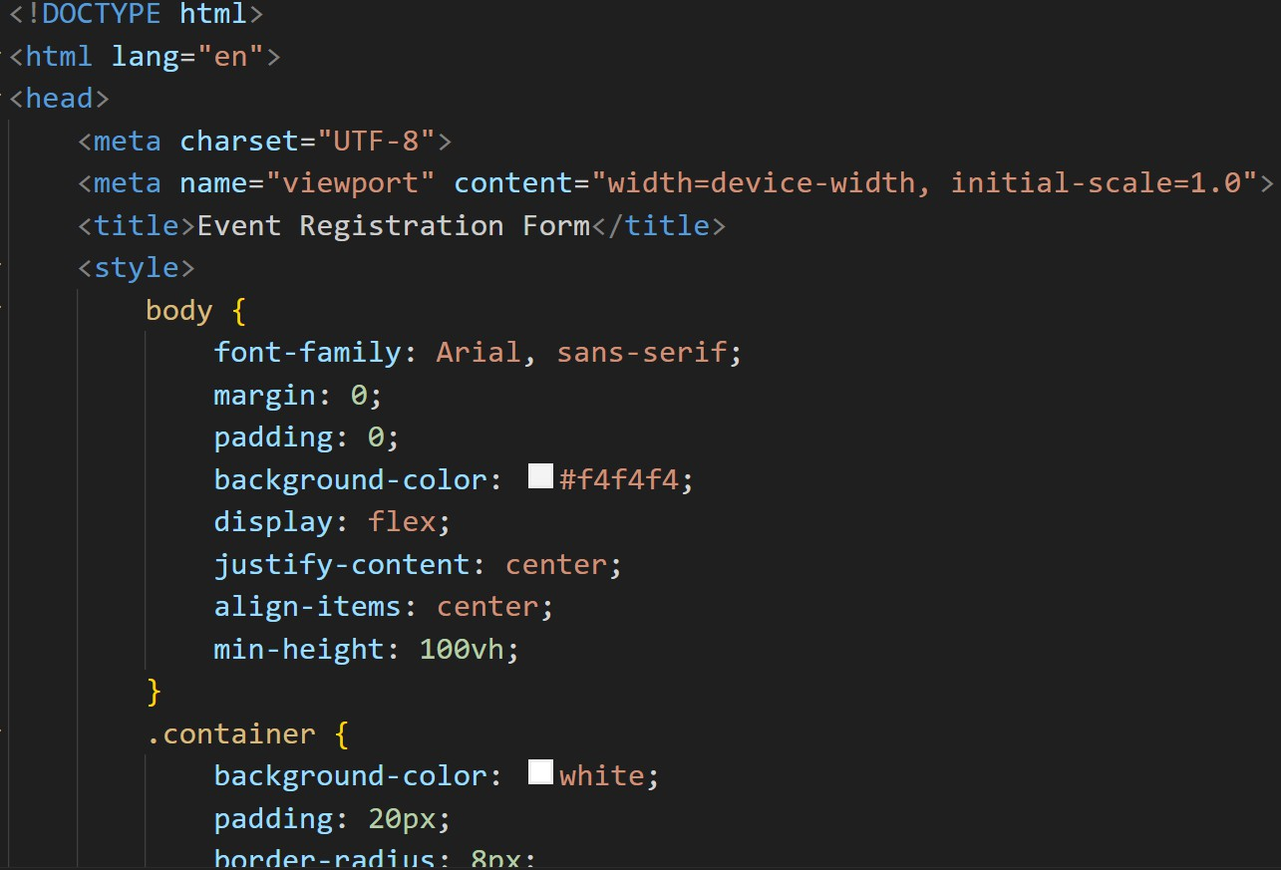
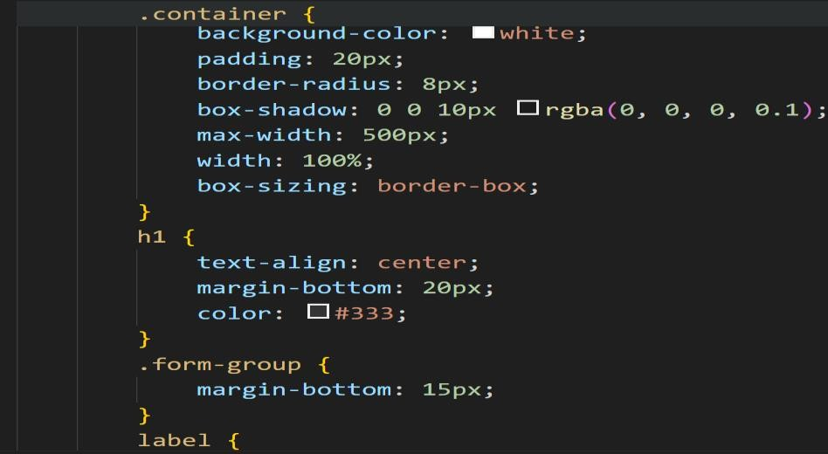
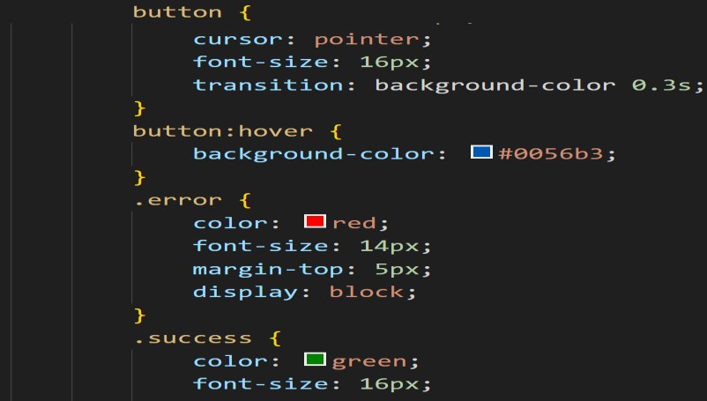

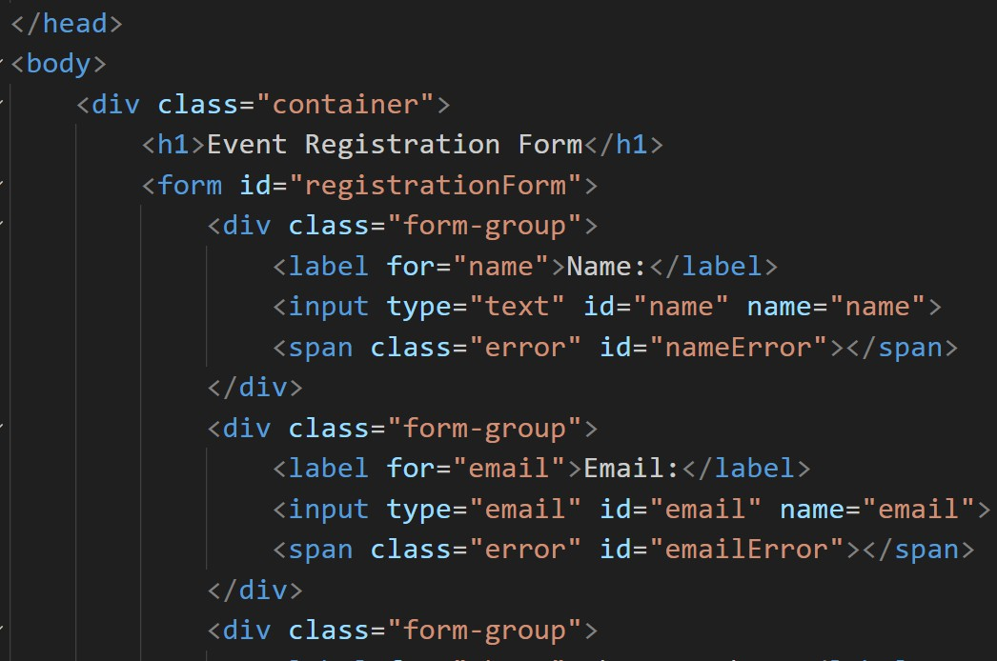
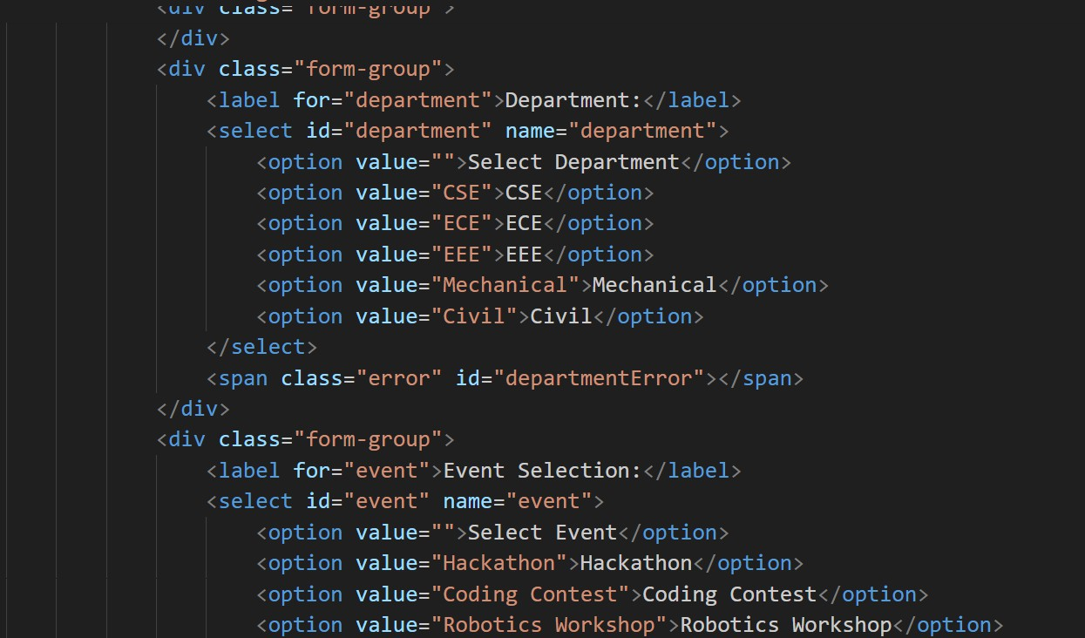

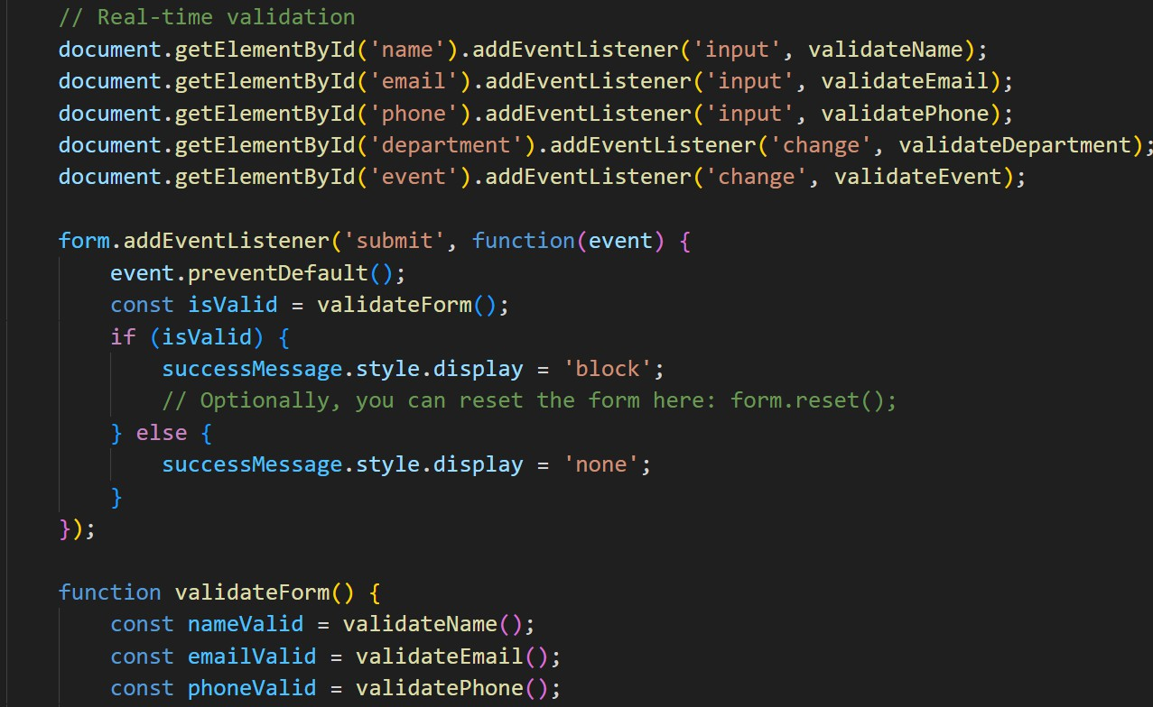
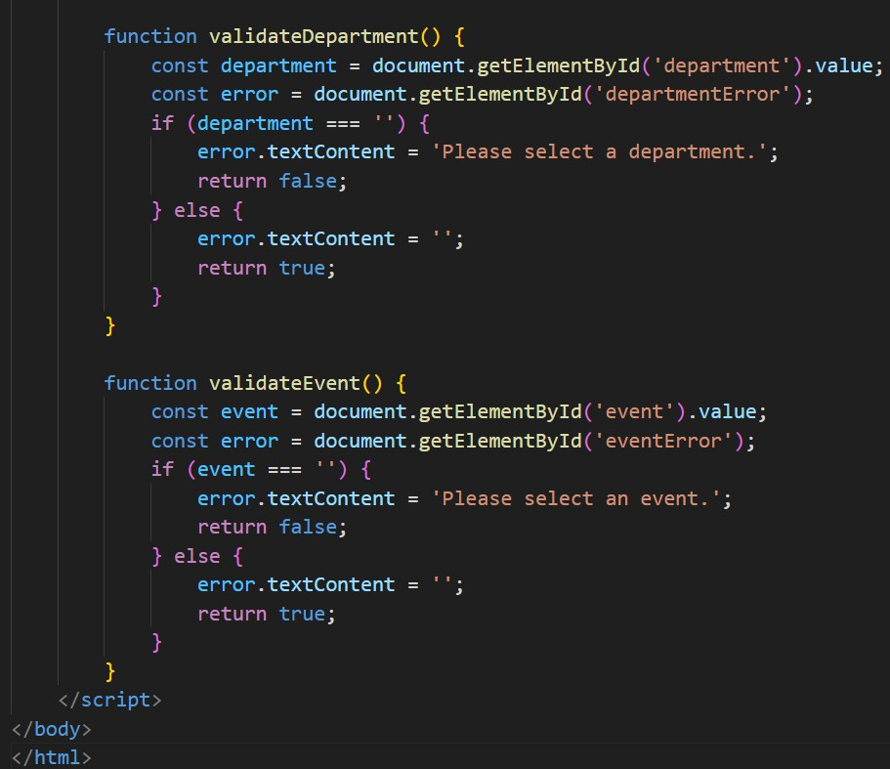
o

OUTPUT:
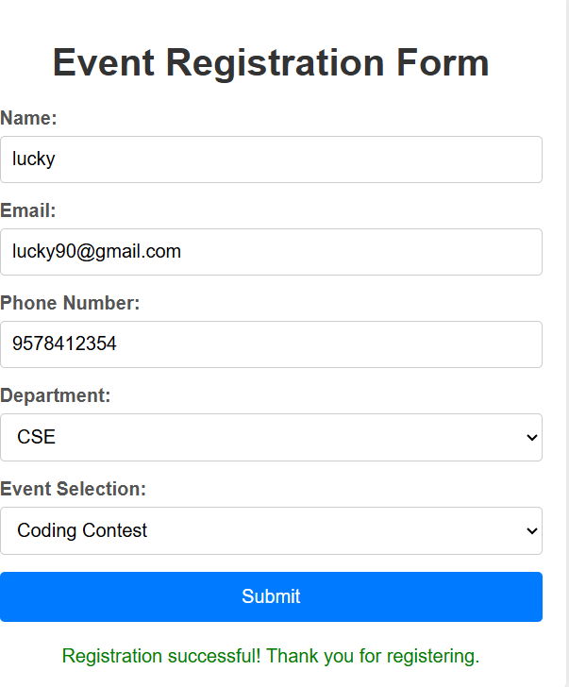
EXPLANATION:
This task develops an AI-powered event registration form for a technical fest using HTML, CSS, and JavaScript. The form allows participants to enter important details such as name, email address, phone number, department, and selected event. CSS styling is applied to make the form visually appealing, organized, and easy to use on different screen sizes. JavaScript validation is implemented to ensure correct user input by checking the email format, validating the phone number length, and preventing form submission if required fields are empty.

Task 4: AI-Assisted E-Commerce Product Page
Scenario
A startup is developing a basic e-commerce product page to showcase products and manage simple cart functionality.
Tasks
- Use Copilot to generate a grid-based product catalog using HTML and CSS.
- Implement an “Add to Cart” feature using JavaScript.
- Modify AI-generated code to include:
  - Cart item counter at the top-right corner
  - Visual feedback when a product is added Expected Outcome
- Functional product catalog
- Working cart counter
- Interactive user experience
PROMPT:
Generate a basic E-Commerce Product Page using a single HTML file with HTML, CSS, and JavaScript.
Requirements
- HTML Structure
  - Create a product catalog displaying at least 6 products.
  - Each product should include:
    - Product Image
    - Product Name
    - Short Description
    - Price
    - Add to Cart button.
- Product Layout
  - Use CSS Grid or Flexbox to design a grid-based product catalog.
  - Ensure products are displayed in responsive cards.
- Cart Feature
  - Implement an “Add to Cart” functionality using JavaScript.
  - When the user clicks the Add to Cart button, the item should be added to the cart.

- Cart Counter
  - Add a cart icon with an item counter at the top-right corner of the page.
  - The counter should increase automatically whenever a product is added.
- Visual Feedback
  - Show visual feedback when a product is added to the cart.
    - Example: change button text to “Added” or show a small notification message.
    - Add smooth animations or transitions.
- Styling
  - Write CSS inside a <style> tag.
  - Use modern UI design with shadows, hover effects, and spacing.
  - Make the page responsive for mobile and desktop screens.
- JavaScript
  - Write JavaScript inside a <script> tag at the bottom of the HTML file.
  - Handle the cart counter update and visual feedback.
CODE:
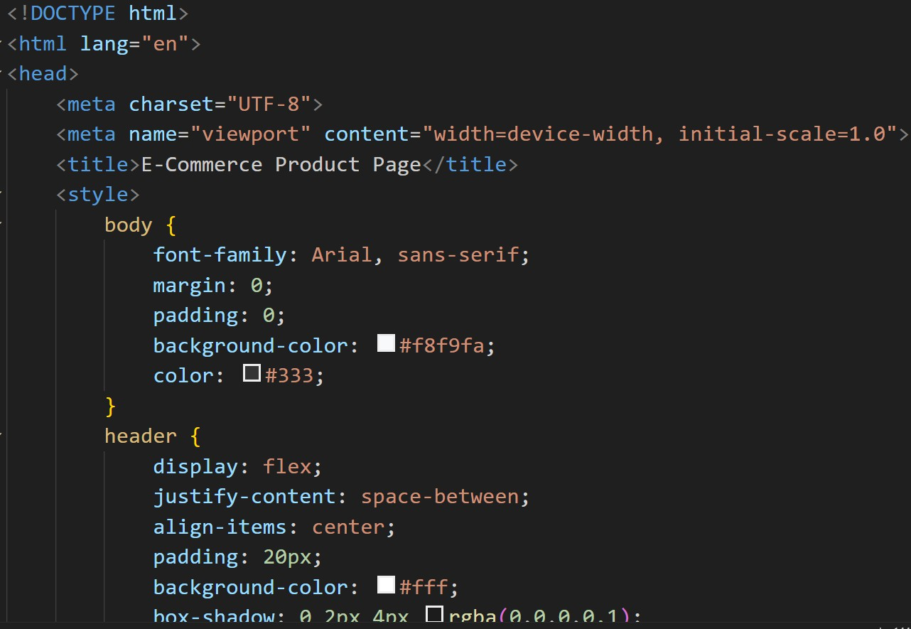

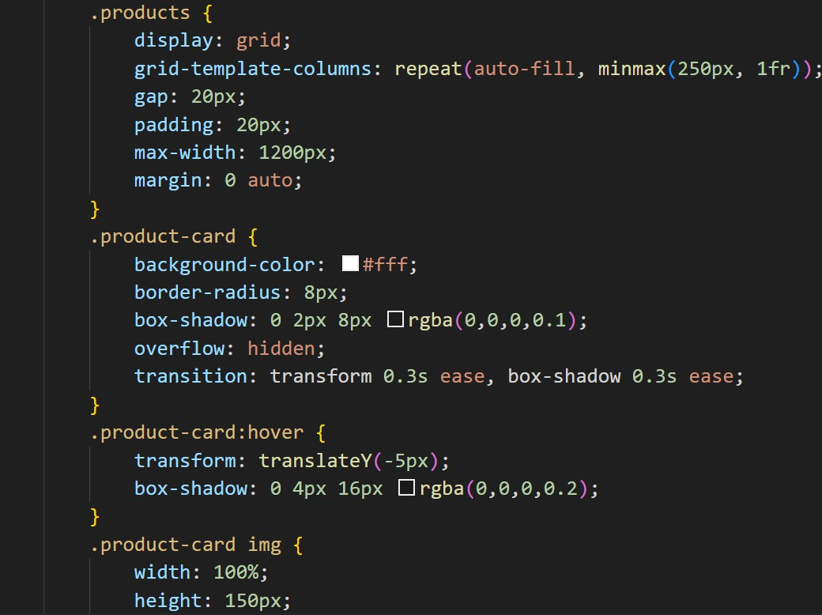
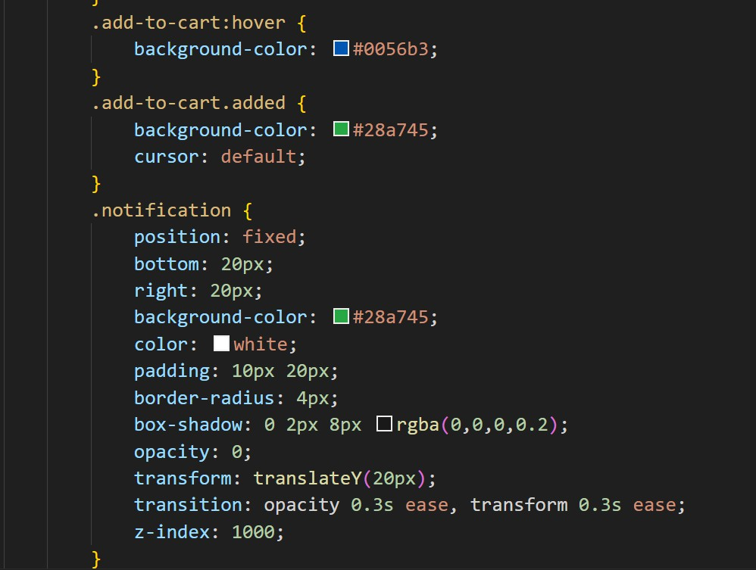

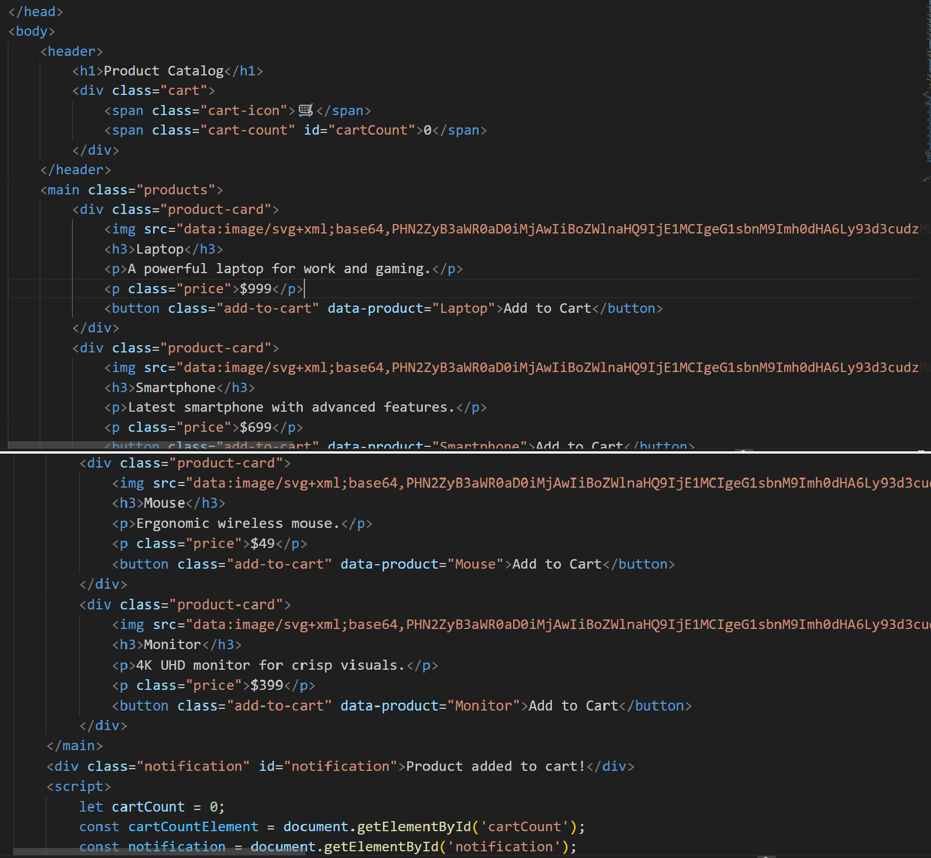
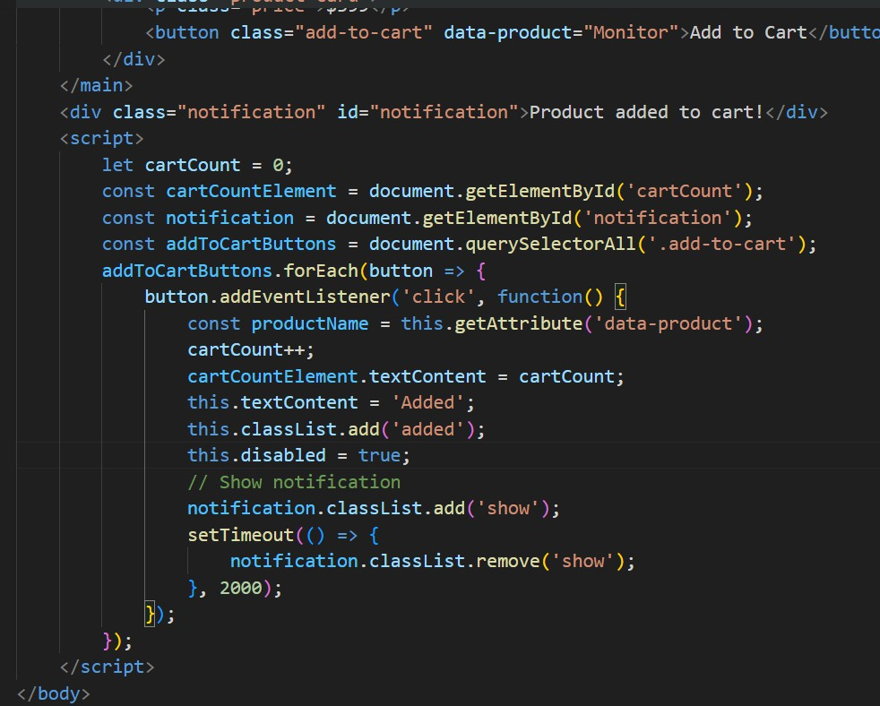

OUTPUT:
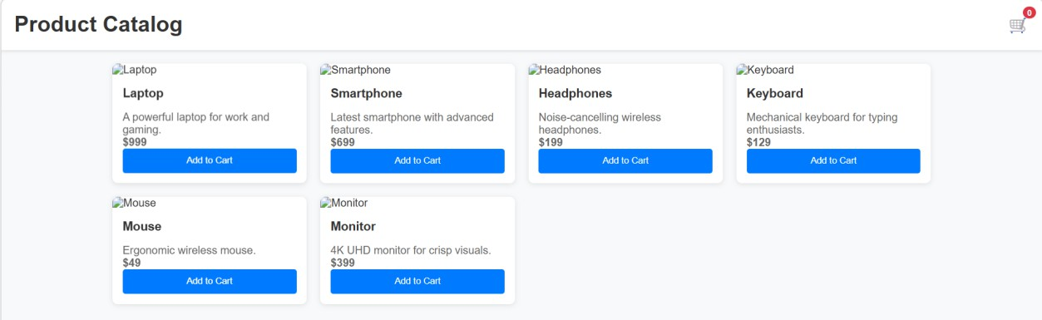
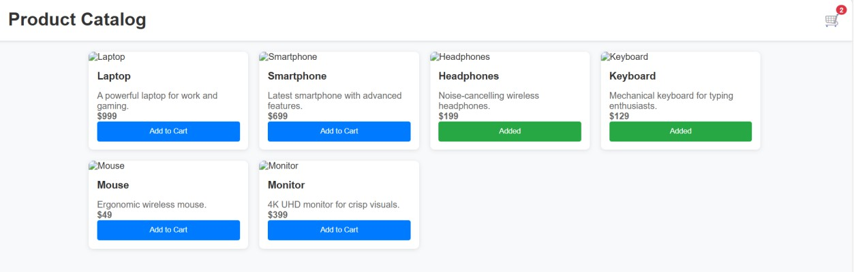

EXPLANATION:
This task develops a basic e-commerce product page using HTML, CSS, and JavaScript to display products in an organized way. The products are arranged in a grid-based layout using CSS, where each product card contains an image, product name, description, price, and an “Add to Cart” button.
JavaScript is used to implement the cart functionality, which increases the cart counter whenever a
user adds a product. Additionally, visual feedback is provided by temporarily changing the button text and colour when a product is added, creating a more interactive and user-friendly shopping
experience.

Task 5: Create a Responsive Web Page Layout
Instructions:
- Design a basic web page layout with a header, main content area, and footer using HTML and CSS
Use AI to assist in generating responsive CSS for different screen sizes.
- Ensure the layout is clean and visually organized. Expected Output:
- A responsive web page with:
- Header with navigation links
- Main section with placeholder text/images
- Footer with copyright or contact info

- Layout adapts correctly to desktop, tablet, and mobile screen sizes.
Note: Report should be submitted as a word document for all tasks in a single document with prompts, comments & code explanation, and output and if
required, screenshots. Use AI to assist in generating responsive CSS for different screen sizes.
- Ensure the layout is clean and visually organized. Expected Output:
- A responsive web page with:
- Header with navigation links
- Main section with placeholder text/images
- Footer with copyright or contact info
- Layout adapts correctly to desktop, tablet, and mobile screen sizes.
PROMPT:
Generate a responsive web page layout using HTML and CSS in a single HTML file. Requirements
- HTML Structure
  - Use semantic HTML5 elements.
  - Create the following sections:
    - Header with a website title and navigation links (Home, About, Services, Contact).
    - Main Content Section with placeholder text and one or two placeholder images.
    - Footer with copyright information or contact details.
- Navigation
  - Add a navigation menu inside the header.
  - The navigation links should be horizontally aligned on desktop screens.
- Responsive Design
  - Write CSS inside a <style> tag in the same HTML file.
  - Use Flexbox or CSS Grid to structure the layout.
  - Implement media queries for different screen sizes:
    - Desktop
    - Tablet
    - Mobile
  - On smaller screens, the navigation menu should stack vertically.
- Styling

  - Use a clean and modern layout with proper spacing, padding, and colors.
  - Add basic hover effects for navigation links.
  - Ensure the page is visually organized and easy to read
CODE:
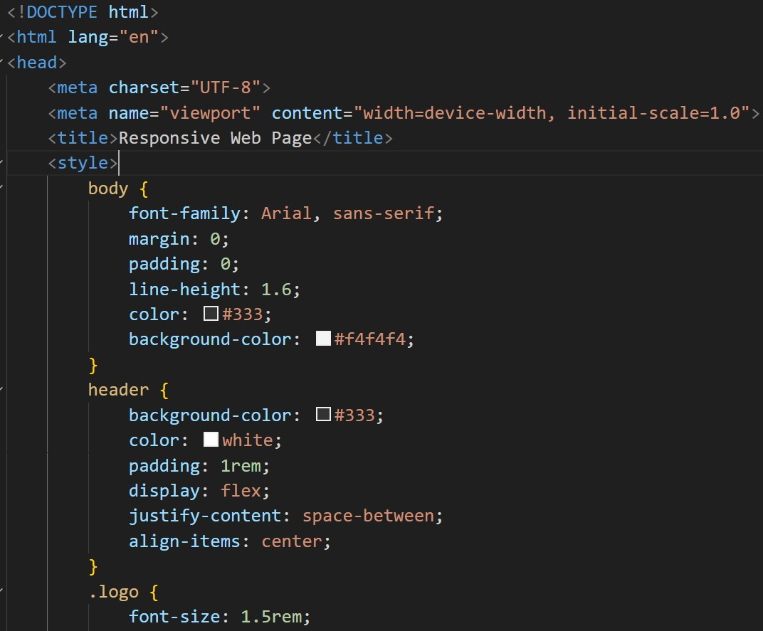
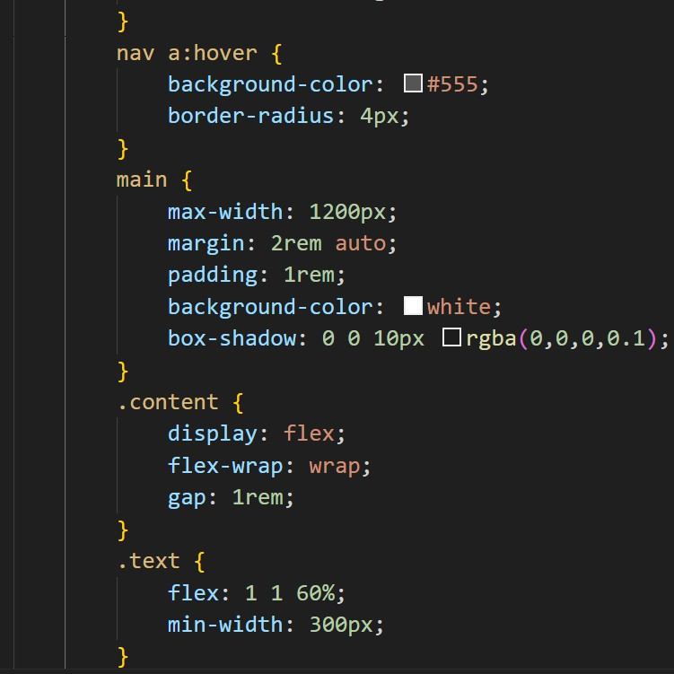

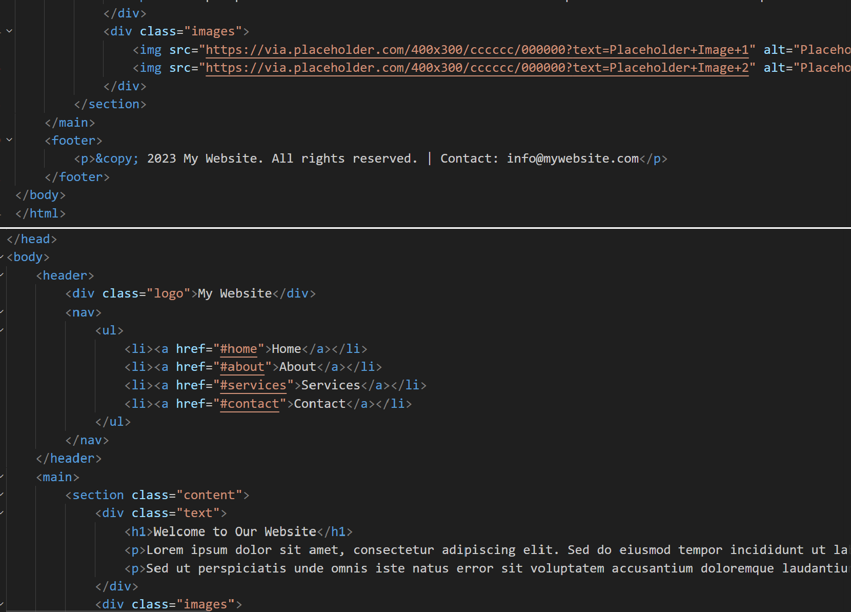
OUTPUT:
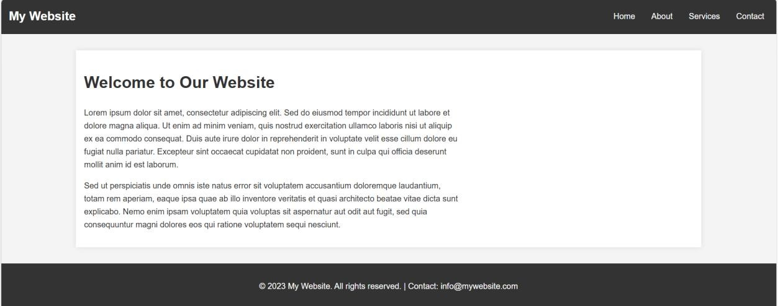
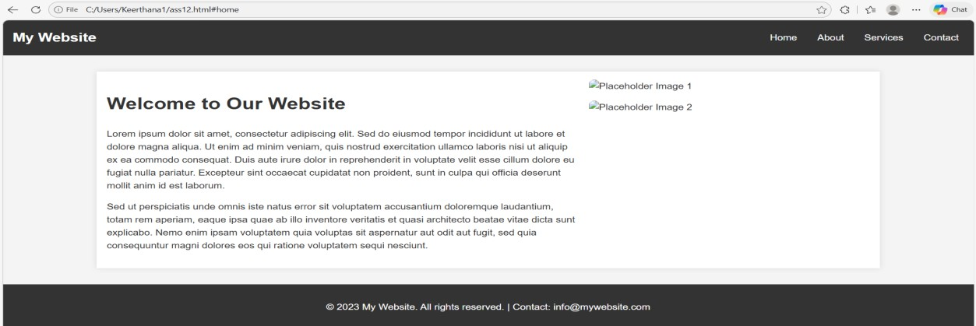

EXPLANTION:
This task creates a responsive web page using HTML and CSS. The page contains a header with navigation links, a main section with sample text or images, and a footer with copyright or contact information. CSS is used to style the layout and make the page look clean and organized. Media queries are used to make the webpage adjust properly for desktop, tablet, and mobile screens.

